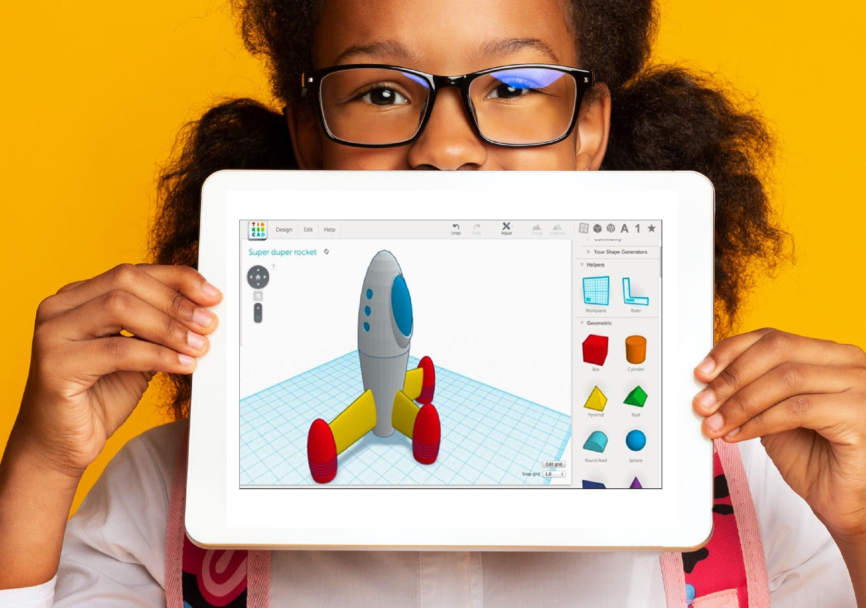

NAME of District/Org/School

NextWaveSTEM Partnership Proposal

School Year DATES

Group

DATE

DISTRICT/ORG

Attn: NAME

ADDRESS

ADDRESS

Dear NAME:

NextWaveSTEM (NWS) is delighted to be considered as a STEM program partner by the DISTRICT/ORG and its #### students and # schools representing various socio-economic backgrounds. Our STEM education solution for your PROGRAM TYPE will show how the NWS experience sparks inspiration and curiosity in students. Students will explore emerging technologies through classroom hands-on learning that integrates the essential skills of STEM into the traditional K-12 programs.

NWS is a national K-12 STEM company and a certified minority-owned enterprise business (MBE). Our accredited programs have proven its ability to effectively teach its STEM courses to both students and teachers across 25 states, and to rapidly adjust to ever-changing educational needs.

* Curriculum includes teacher guides, student materials, and other resources for an easy implementation by educators. Demo accounts can be accessed on our teacher portal at <https://nextwavestem.com/free-curriculum-stem-samples>.
* Each course, with 15 one hour lesson plans, can be expanded by adding additional courses to cover desired duration of instruction and using it with unlimited sections of students. It is designed for K-12 students with differentiation among the grade levels.
* Courses come with hands-on student equipment for classroom sizes with up to 24 students meant to be reused in subsequent lessons.
* Site licenses include yearlong access to our teacher portal that include all of our courses with teacher classroom guides, presentation slides, and student worksheets.
* Professional development requires only 3 hours of live and/or pre-recorded training for your teacher and unlimited coaching and support for the length of the annual site license.
* Our pricing model for our turnkey STEM programs includes the course, student equipment, and live professional development as a bundle.
* Pre-purchasing renewals for subsequent years includes a 15% discount on live professional development and courses that we maintain and update on our learning management platform.
* We can bridge the gap by providing skilled STEM instructors, who are trained to lead programs at our partnerships sites, especially where there are teacher shortages.

Our courses foster STEM learning through hands-on activities that help students develop the curiosity and creativity they will need in post-secondary education and careers. Many students today will work in careers that do not yet exist, and our courses help to prepare learners using emerging technologies. Drones, robots, and 3D printers in the classroom allow students to build, code, play, and learn to make important connections to the real world.

NWS programming reinforces concepts from the classroom, but also further challenges and engages learners in STEM topics. More than 2,500 teachers and 125,000 students have already participated in our emerging technology programming! NWS is committed to making STEM learning an enriching and exciting experience for both educators and students in your district.

Sincerely,

NAME, TITLE

EMAIL

**Company Overview**

NextWaveSTEM (NWS) is committed to increasing equitable access to science, technology, engineering, and math education for K-12 students. NWS provides accredited curriculum and industry equipment kits with teacher training that enable K-12 school districts to implement learning with drones, robotics, 3D design and printing, coding and programming, game design, and renewable energy. Curriculum is aligned with state and national education standards, ensuring that students are engaging in a high-quality education experience that meets established benchmarks. NWS programs are flexible, spanning the school day, after school programs, and summer camps. Furthermore, we bridge the gap by providing skilled STEM instructors, who are trained to lead programs at our partnerships sites, especially where there are teacher shortages. NWS’ innovative approach leverages emerging technologies to ignite a passion for learning, laying a critical foundation for 21st century skill development, and unlocking a world of STEM career opportunities for students.

**Experience**

NextWaveSTEM’s (NWS) experience is demonstrated by having successfully served K-12 schools across the country since our founding in 2017 by launching after school programs. NWS has achieved a 5 star vendor status in 80 schools within the Chicago Public School district and received accreditation from stem.org. Recognized for our unique K-12 STEM products and services, NWS has expanded to over 500 schools and districts in 25 states, helping more than 125,000 students explore emerging technologies.

NWS courses are designed to integrate with in-school assessment based instruction and grade-level content by conforming to Next Generation Science Standards, Common Core State Standards, CSTA, ISTE, and 21st Century skills. Our courses use these standards as a guideline for taxonomically appropriate, student driven instruction that creates opportunities to build awareness and explorations of real-world applications of emerging STEM technologies. Courses build upon each to create a progression of knowledge and learning pathways among grade bands.

Teachers, who often lack or cannot access STEM training, receive continuing education credit through our district partnerships and effectively support ongoing STEM education in their schools. NWS has trained over 2,500 educators in STEM. By combining effective and relevant in-class technologies, teachers are empowered to present introductory, and intermediate concepts in physics, renewable energy, computer science, engineering, and entrepreneurship in ways that allow for students to explore and fail without fear.

NWS monitors emerging technologies and evolves curriculum to ensure the students are getting the latest knowledge to develop an appropriate STEM foundation in real-world contexts. NWS delivers solutions with a “what is best for the student” mindset. Awarded the Enrichment Partner of the Year 2020 by the Chicago Hopes for Kids organization with former NASA Astronaut Leland Melvin present, NWS continues to deliver timely results to students in the pursuit of quality STEM Learning.

Schools report improved student attendance, students more willing and interested in increased depth of STEM courses, and teachers who are more confident in effectively teaching STEM education. For about 90% of students, NWS was their first experience with technology and engineering, part of STEM. Assessments demonstrate that 85% of students show an interest in STEM careers after taking NWS courses.

NWS education products and instructor training can be repeated, extended, and scaled across differing communities and/or populations, and provides support to educators, families, and other implementaters. Our turnkey solutions and services include everything to implement STEM during the school day, after school, and in the summer. NWS’ programs align with its vision of empowering the next generations to succeed in high school and graduation, and innovate and excel in our increasingly technical world.

Overview of Proposed Courses

All NWS courses include topics and activities that touch on a multitude of subject areas. The overall curriculum model follows the 5E framework: Engage, Explore, Explain, Elaborate, and Evaluate. From a Lesley University article on the 5E curriculum model:

“The 5E Model promotes collaborative, active learning in which students work together to solve problems and investigate new concepts by asking questions, observing, analyzing, and drawing conclusions. The 5E Model is based on the constructivist theory of learning, which suggests that people construct knowledge and meaning from experiences. By understanding and reflecting on activities, students are able to reconcile new knowledge with previous ideas” ([*https://lesley.edu/article/empowering-students-the-5e-model-explained*](https://lesley.edu/article/empowering-students-the-5e-model-explained)*).*

Checks for understanding are frequent and in multiple forms - verbal, written, and performance based. Most lessons include pre-tests that combine formative and summative assessments. Several units include capstone projects that allow for students to demonstrate their understanding in multiple forms, from performance tasks to presentations to reports.

Courses contain 15 hours of lesson plans that will be taught by instructors. Courses are aligned to NGSS, ISTE, Common Core Math and ELA, CSTA, and multiple State Standards. NWS’ emerging technology curriculum is described below:

Grades K-2 | Introduction

Early learners are introduced to basic knowledge and understanding of what robots, drones, and AI are and do.

Introduction to Robots: What is a Robot?

Early learners explore the world of robotics—what are robots, how do they work. and what can they do? During the course, early elementary students will use their Colby robots to draw numbers, tell a story, hunt for treasure, and complete other hands-on activities to build their understanding of robotics.

Introduction to Drones: Take Flight!

For our earliest learners, drone technology may seem fantastic but is an amazing way to explore the science of flight and learn more about the world around them. By learning about the fundamental forces of flight, and flying their hand-operating drones, students start building the foundations for the ways drones are used every day.

Introduction to Innovation: STEM Classics

This course offers a collection of hands-on, design-based activities that foster critical thinking, creativity, and collaboration among young students. Through various projects, students will engage in ideation and iteration, learning to solve problems and improve their designs. The activities are designed to be fun and educational, providing a strong foundation in STEM principles.

Introduction to 3D Printing: Create and Construct with Early Engineering Adventures

This course introduces young learners to the fundamentals of engineering through hands-on activities that explore 3D shapes, materials, size and scale, art, and prototyping. Students will develop spatial reasoning and problem-solving skills as they engage in creative building projects using various materials.

Introduction to AI: Lions, Tigers, and AI!

The Zappsville Zoo focuses on protecting and healing endangered animals. Early elementary students will complete hands-on activities introducing them to basic AI, robotics, and machine learning concepts as they solve a variety of zoo-themed challenges!

Introduction to Hydroponics: Plants and the Science of Growing!

Learners will explore many aspects of plants, their needs, and various growing conditions. Early elementary students will be recording their observations and data from their own plant’s progress and students will discover the unique traits of plants and their growth while beginning to delve into the exciting science of hydroponics.

Grades 3-5 | Discovery

Young learners build knowledge and understanding of real-world application and purposes of emerging technologies.

Discovery of Robotics: Coding mBot

Young learners explore construction and coding through the world of robotics. Students will create a robot that tracks and follows a line, respond with sound, flashlights, and compete in a series of robot tasks and challenges.

Discovery of Unmanned Aviation

This course is designed for learners to answer the question: How do drones work? Students will develop an understanding of how drones’ function and learn how to program drone flight through coding in the Tello application. This course uses Scratch based coding.

Discovery of Game-Design: Video Games from “Scratch”

Students will learn the basics of block coding using Scratch as they modify and customize a variety of video games. Through 15 engaging lessons, students will design custom levels, characters, rules, and controls, bringing their game ideas to life. The course emphasizes creativity and problem-solving, providing students with the skills to create the game of their dreams.

Discovery of 3D Design Using Tinkercad

This course is wonderfully crafted for learners to answer the question: What is Tinkercad and how does it work with 3D Printing? In a full detail, learners will bring their ideas to life from a blank 3D design canvas to a full physical printout with use of Tinkercad and Thingiverse.

Discovery of Solar Power and Renewable Energy: Designing Systems

Understanding connected systems of energy is critical to our students' future health, wealth, and happiness. Practices that get clean power where it needs to go are essential to humanity’s continued growth. Students will gain hands-on and build a working model of a solar-powered energy system to learn more about connected power infrastructure.

Discovery of AI: ARTificial Intelligence Artists

When science and art merge, what do we get? Wonder. Students will explore various artistic mediums and the core concepts of artificial intelligence as they unleash their inner creative through "wonder"-based lessons.

Discovery of Hydroponics: Plants and the Science of Growing!

Learners will explore plant growth, biology, and agriculture. Students will explore the many aspects of plants, their needs, and various growing conditions through the exciting science of hydroponics.

Grades 6-8 | Exploration

Students analyze emerging technologies uses and evaluate their affordances and effectiveness in the real world.

Exploration of Robots: Coding mBot for a Purpose

Students answer questions such as, “What can a robot do?” and “How can a robot be coded to do so?” Students learn to code in the mBlockly application and program their own mBot robots for a specific purpose.

Exploration of Drones: Coding With Tello

Students explore and apply how Unmanned Aerial Vehicles (drones) are used and function. Students integrate algebraic thinking, programmatic knowledge, and use case scenario abstraction to control drones in Droneblocks.

Exploration of Game Design: Coding Arcade with Game Design Essentials

Students will dive into the world of game design by learning both block-based and text-based coding. They will create custom online arcade games, exploring essential game design concepts such as probability, level design, power-ups, and character customization. By the end of the course, students will have developed their own playable arcade games, showcasing their creativity and coding skills. Additionally, game design prepares learners with applicable skills in careers such as computer science, visual art, sound design, marketing, and product development.

Exploration of 3D Development: Using Tinkercad

Students will learn how 3D printers work. Students will answer questions such as, “What is the Engineering Design process?” and “How can I use it to design in 3D printing for a purpose?” Students demonstrate proficiency in using Tinkercad tools from design to print out.

Exploration of Internet of Things (IoT): Designing an IoT Device

Students explore the billions of physical devices around the world that are now connected to the internet, collecting and sharing data. Using engineering design and block coding, students design their own IoT device for uses in society.

Exploration of Invention and Entrepreneurship: From Idea to Market

Students explore what makes something an invention and study the history of some inventions that have shaped our way of life. Students learn problem-identification, problem-solving and creativity skills.

Exploration of AI: AI Tools and Concepts

Students will learn the basics of Artificial Intelligence, Machine Learning, and Chatbots as they train and program their very own virtual characters using Scratch and Machine Learning for Kids. Students will explore text, voice, and image recognition as they craft realistic AI chatbots bursting with personality.

Exploration of Hydroponics: Plants and the Science of Growing!

Students will explore the wonders of plant growth, biology, and agriculture. Students will explore plant anatomy, how they thrive, and what they need to grow without soil.

Grades 9-12 | Creation and Evaluation

Students evaluate and develop design solutions using emerging technologies to solve real-world problems.

Creation and Evaluation of Python Coding and AI

Students learn about computers, artificial intelligence, and their real-life applications. From facial recognition to autonomous cars, they find out that computers and A.I. are everywhere around us!

Coding with Drones: Harnessing Technology for Real-World Problems

Students analyze and apply how Unmanned Aerial Vehicles (drones) work and can be used to solve real-world problems. Students learn how to program drone flight through coding in the Droneblocks application.

Drone Pilot Certification

A comprehensive 15-hour course that equips students with the essential knowledge to pass the FAA Part 107 exam. Topics include the aviation industry, FAA regulations, airspace classification, map reading, pre-flight procedures, and flight operations.

Creation and Evaluation of 3D Technology for the Real World

Students analyze and apply how a 3D printer works and how it can be creatively used to solve real-world problems. Students will go from a blank 3D design canvas to a full physical print out—making their ideas come to life!

Creation and Evaluation of Cybersecurity: Global Impact

Students will develop and evaluate concepts of cybersecurity and analyze the ethical ramifications of sharing their data through digital networks globally while exploring foundational mathematical concepts and computer science principles in cryptography.

Entrepreneurship and Innovation: Creation of Goods and Services

Students will unlock creative and entrepreneurial potential in this course on innovative goods and services. Students will identify market needs, create functional prototypes, and pitch ideas in a culminating mini project.

Creation and Evaluation of Agriculture Science

A cross-cutting 15-lesson course focused on Agriculture, Food, and Natural Resources. Students will learn about and complete hands-on activities related to soil science, plant biology, irrigation, pest control, sustainability, Agroforestry, land management, and distribution.

Supplies and Materials  
NextWaveSTEM (NWS) will provide all supplies, materials, and equipment needed to implement the program plan. Equipment shipments include Tello drones, mBot robots, batteries, charging docks, and plant kits for student use each day. Additionally, the education team will coordinate with the school access to the following student and classroom needs:

* Classroom space accommodating up to 25 students that include USB tower, electrical outlets, extension cords, HDMI cord, external display, i.e., white board, TV, projector,
* Indoor use for equipment such as robots and drones, with consideration for the impact of thick carpets slowing robot operations
* Access to gymnasiums and cafeterias for flying drones, where applicable
* Accessible devices for students to interact with course materials and operate equipment, including compatibility with specific software and apps
* Coordination with IT departments to ensure necessary software and app access for the program.
* Storage facilities that are secure and lockable, either within designated classroom space or in a separate area
* Reliable internet connectivity and Wi-Fi access